**Design dan Analisis Algoritma**

Nama Lengkap : RIFANDY ARNAS

NIM/NPM : 232310001

Kelas : TI – 23 – PA (Lab 2)

Matkul : Design dan Analisis Algoritma

**PERTEMUAN I**

[TUGAS]

>>>>>>>>>>Bubble Sort<<<<<<<<<<

Berikut adalah screnshoot waktu dan tanggal pembuatan script

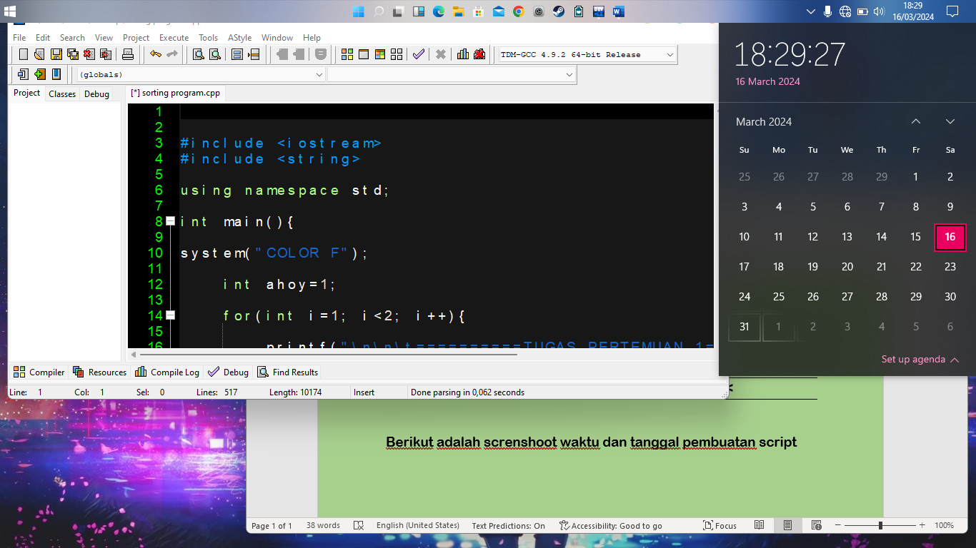

Berikut adalah screnshoot Output dari pembuatan program kali ini

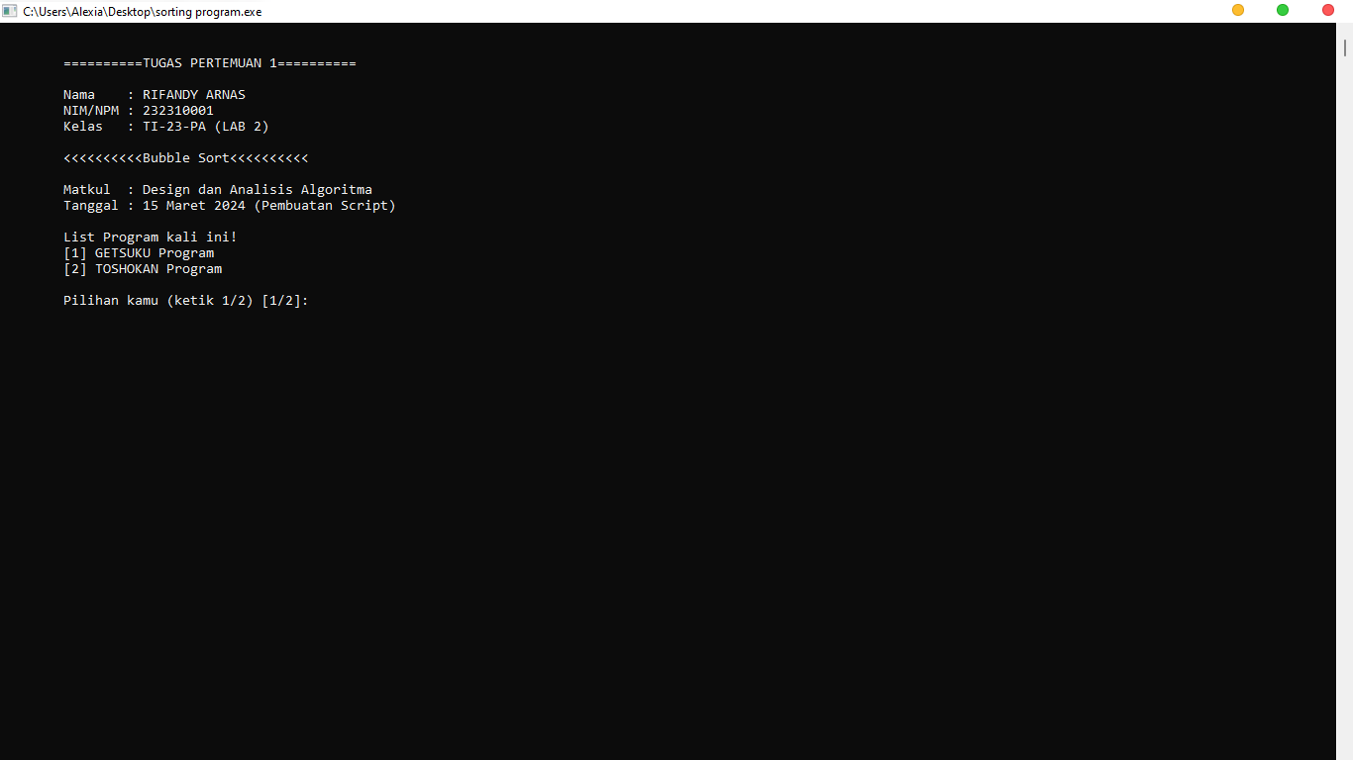

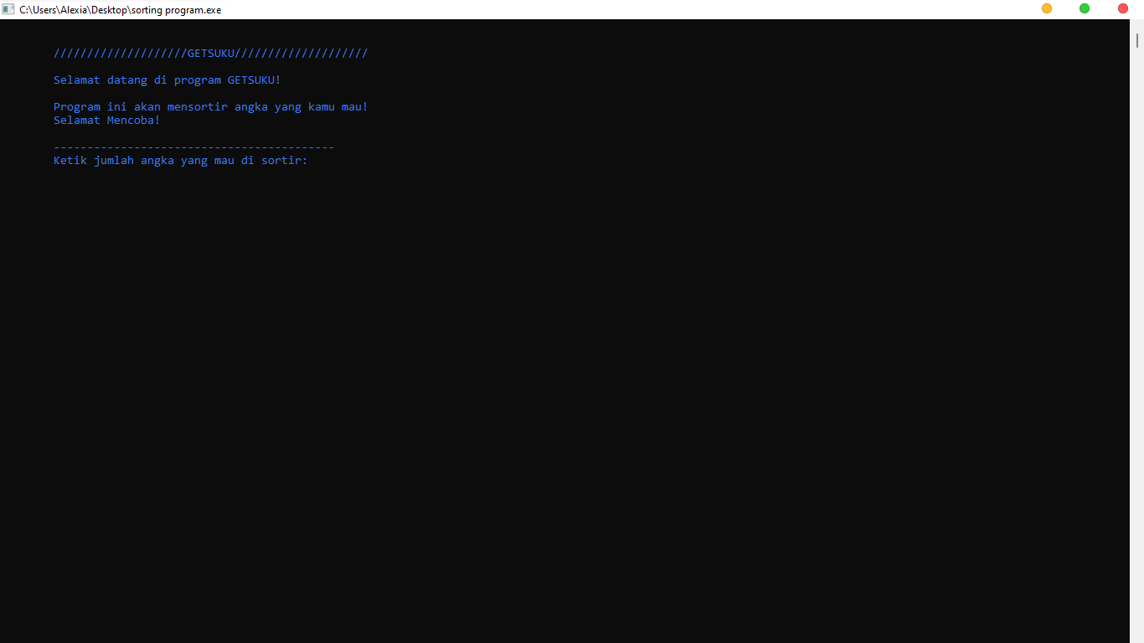

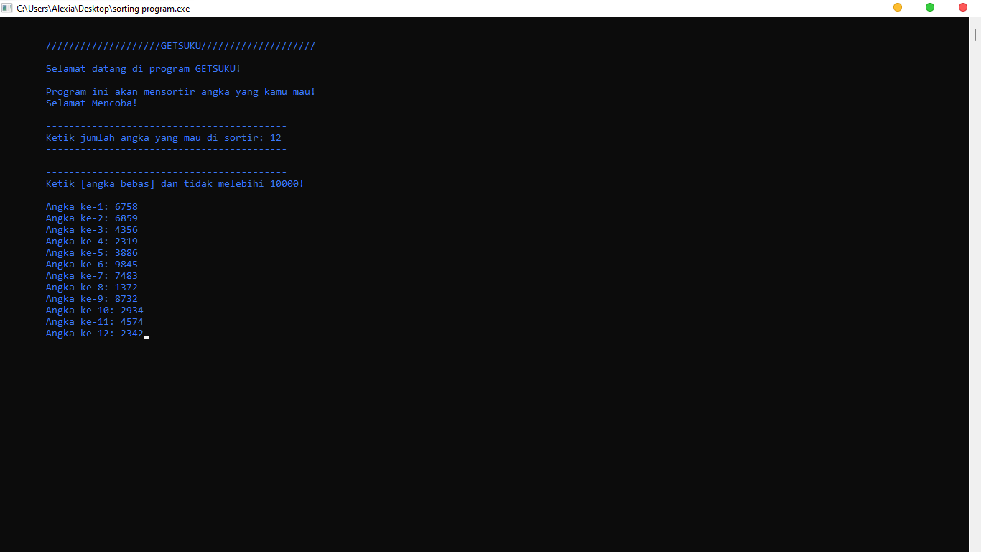

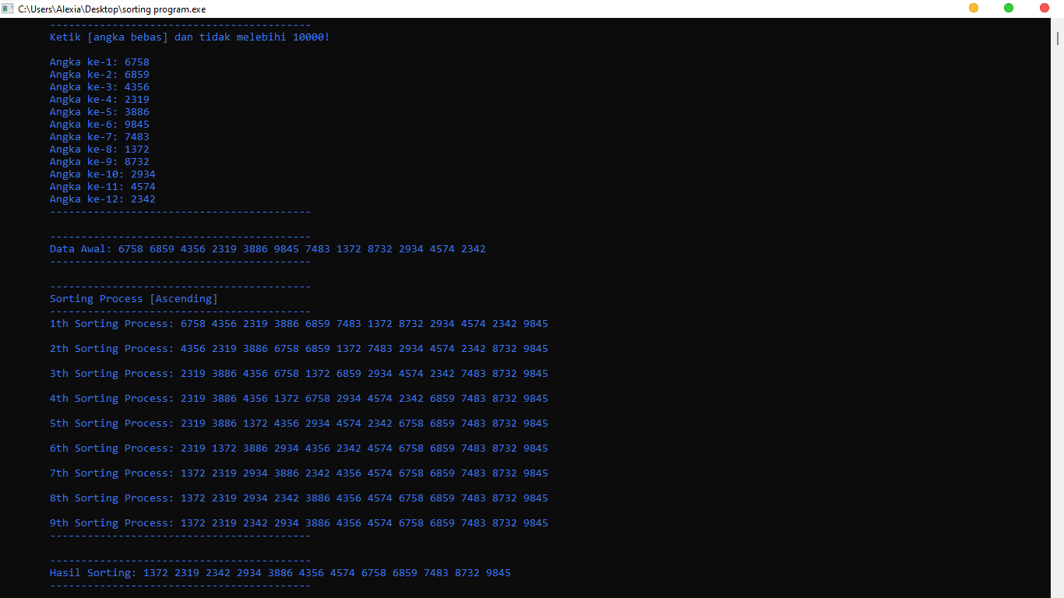

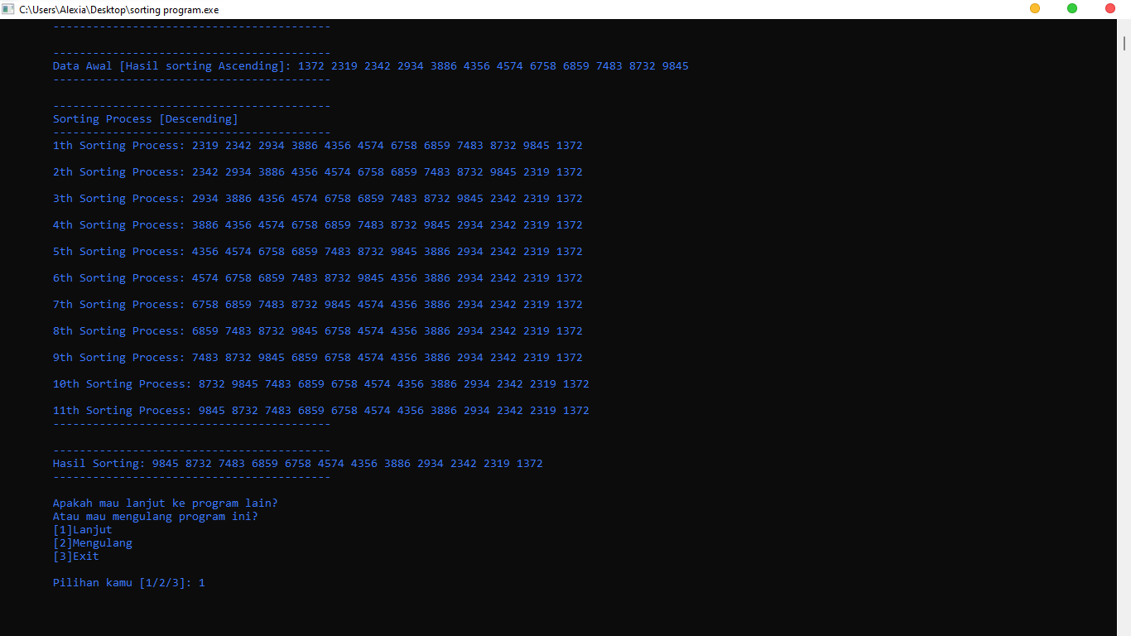

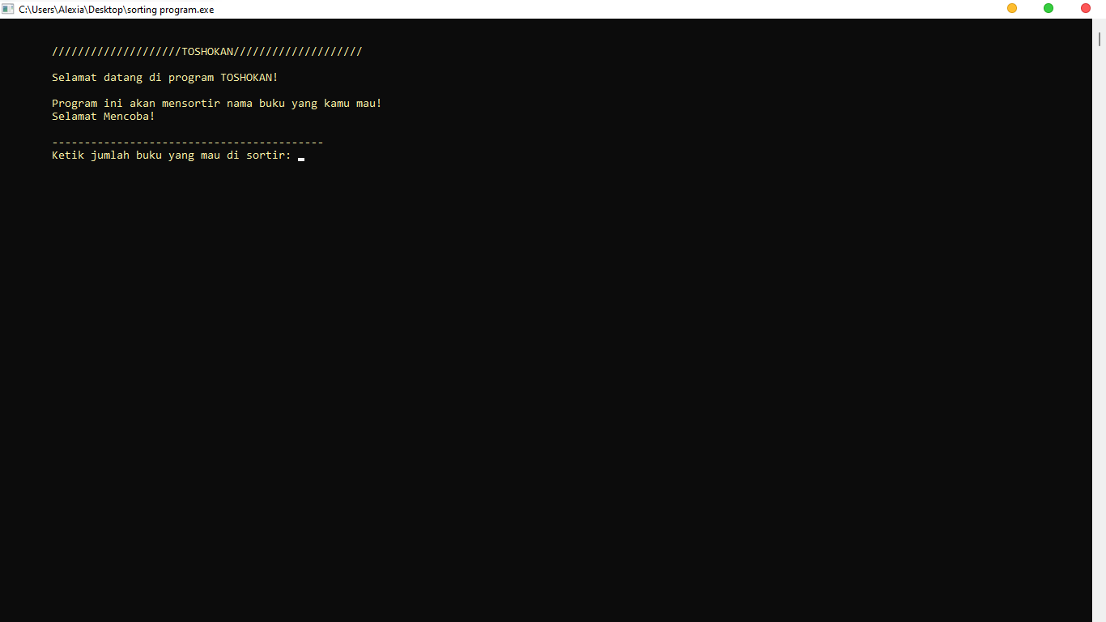

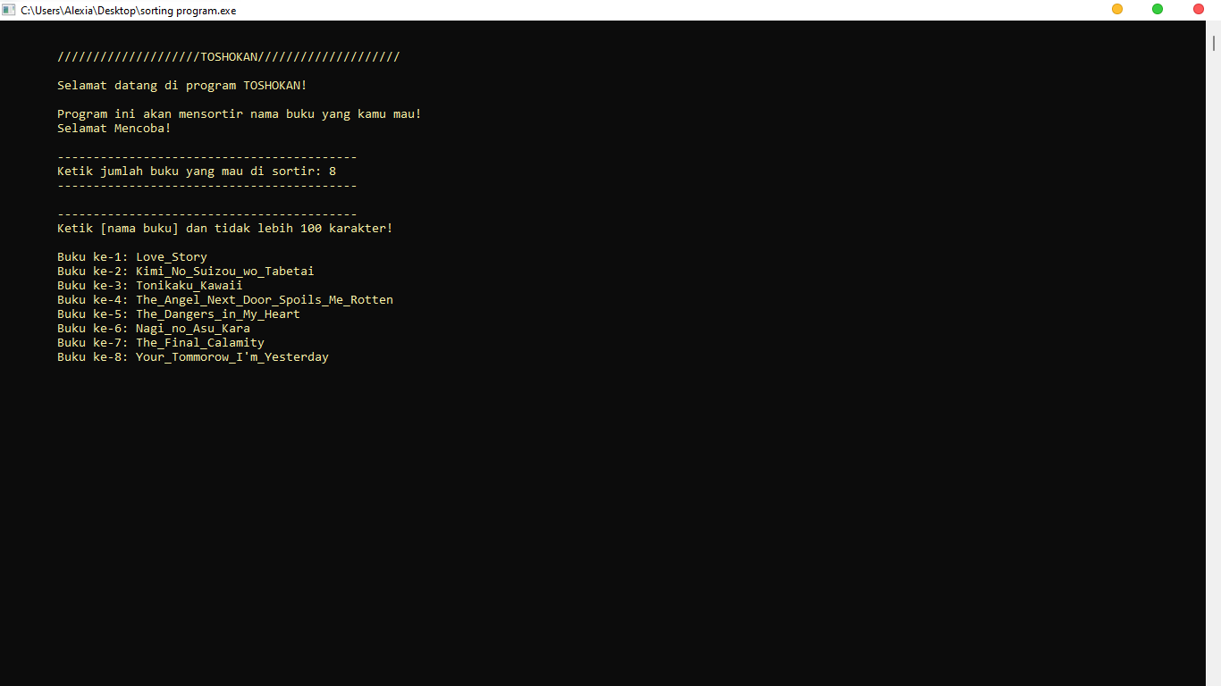

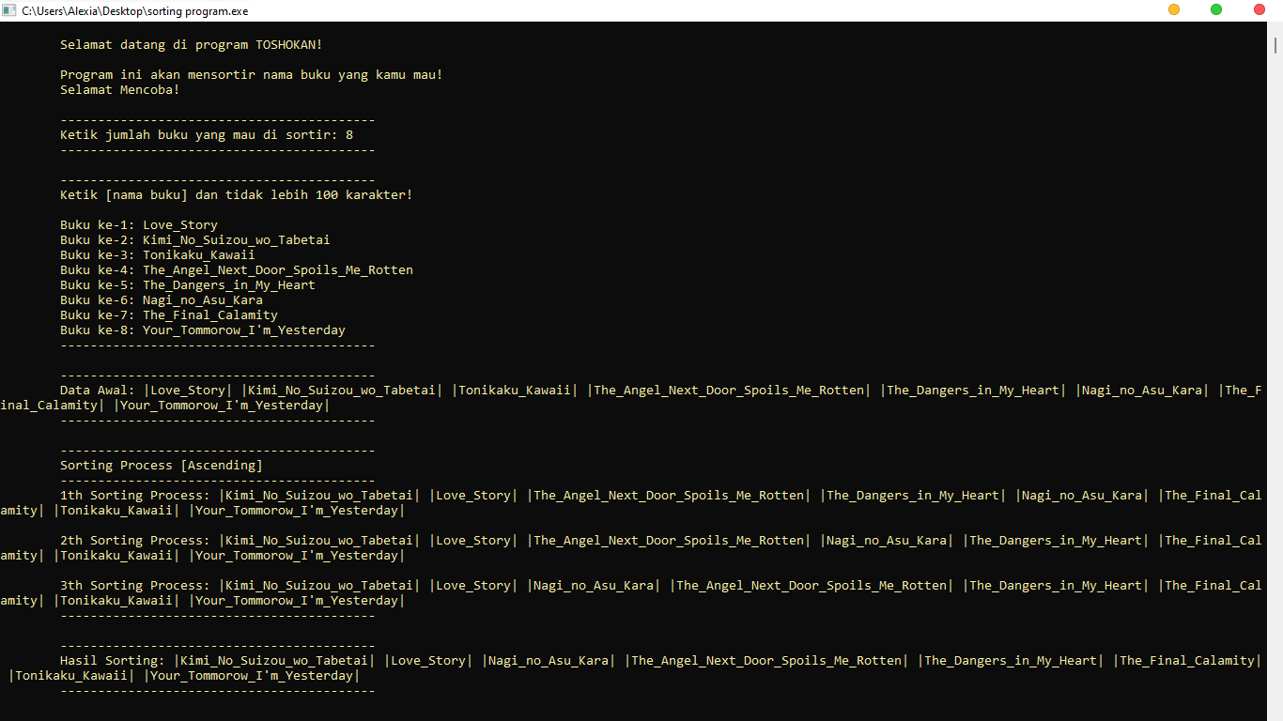

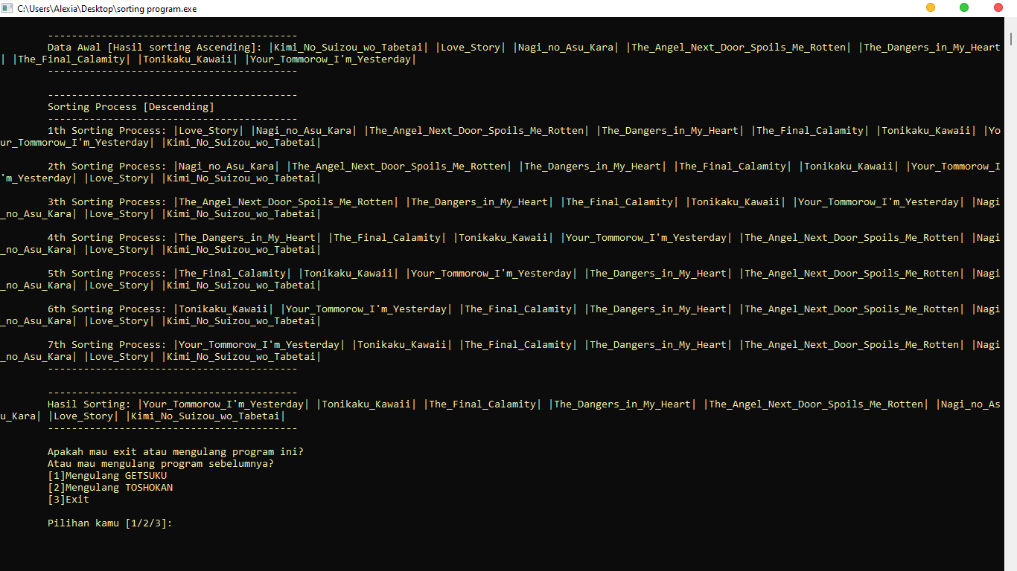

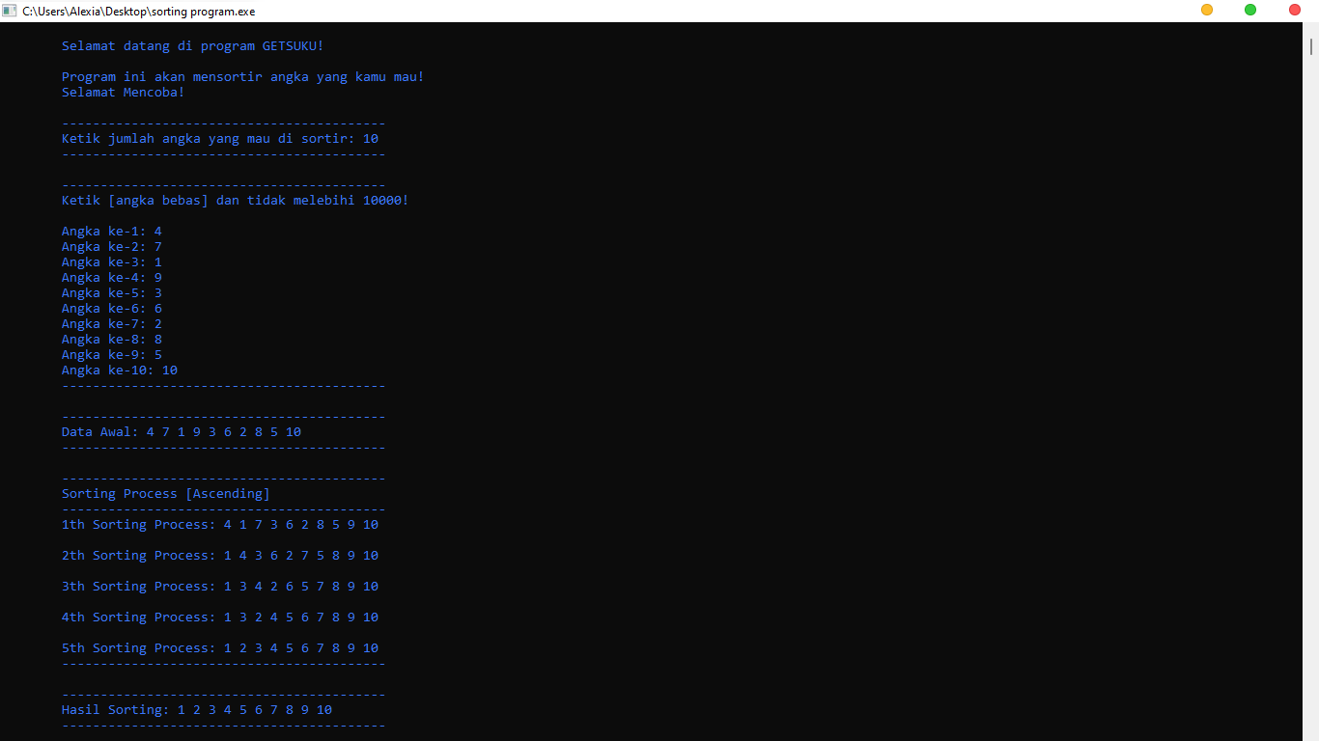

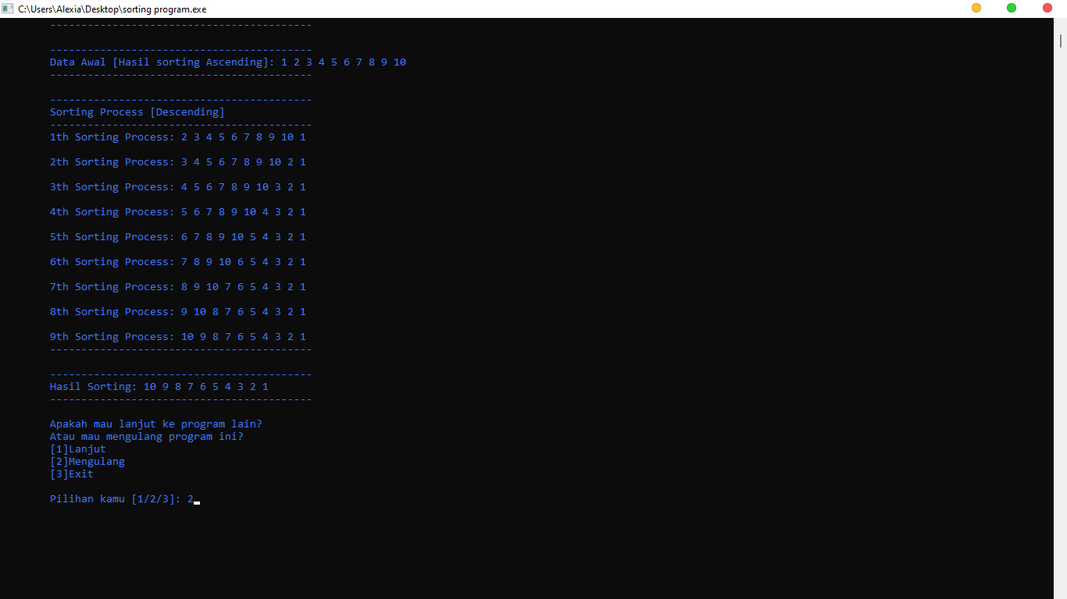

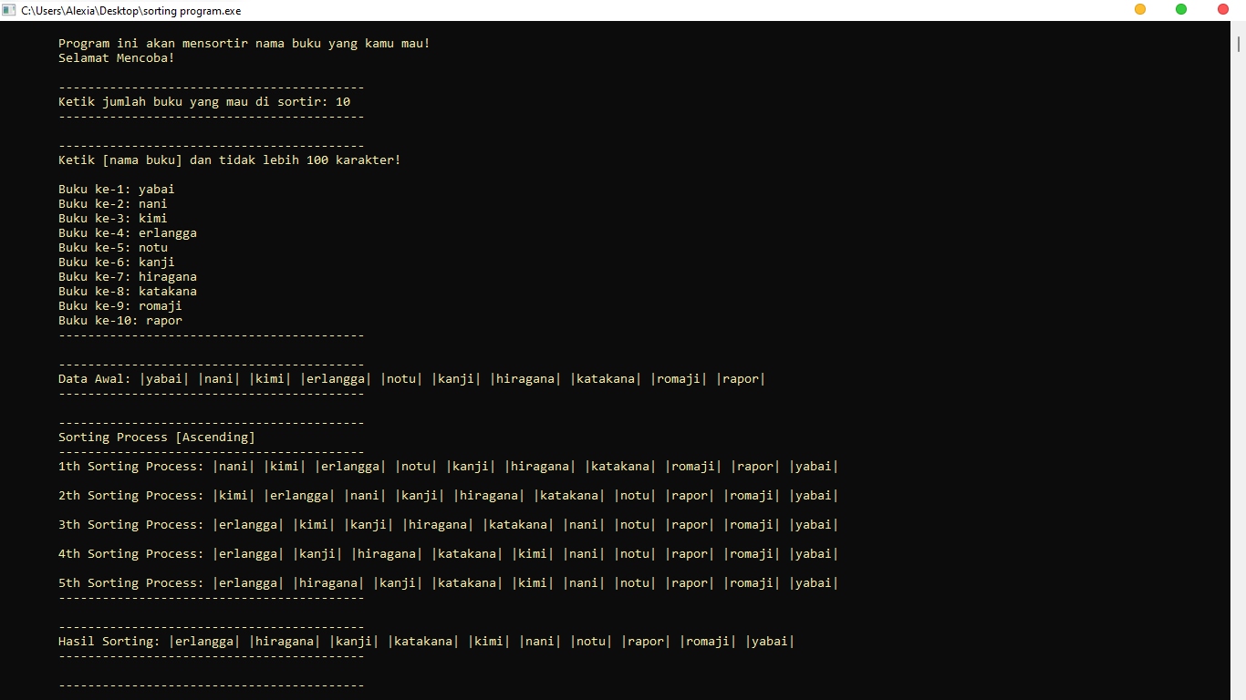

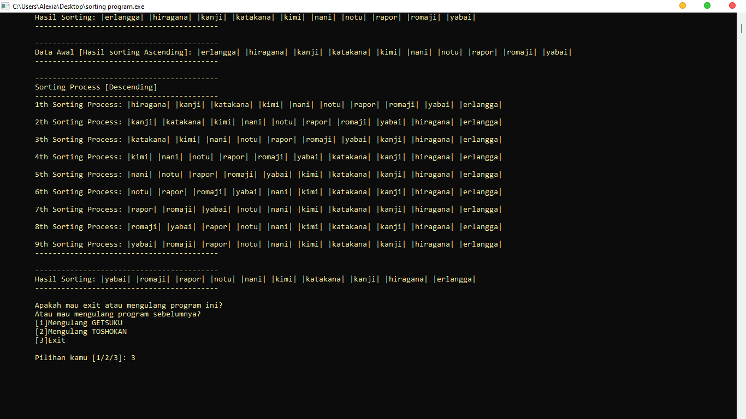

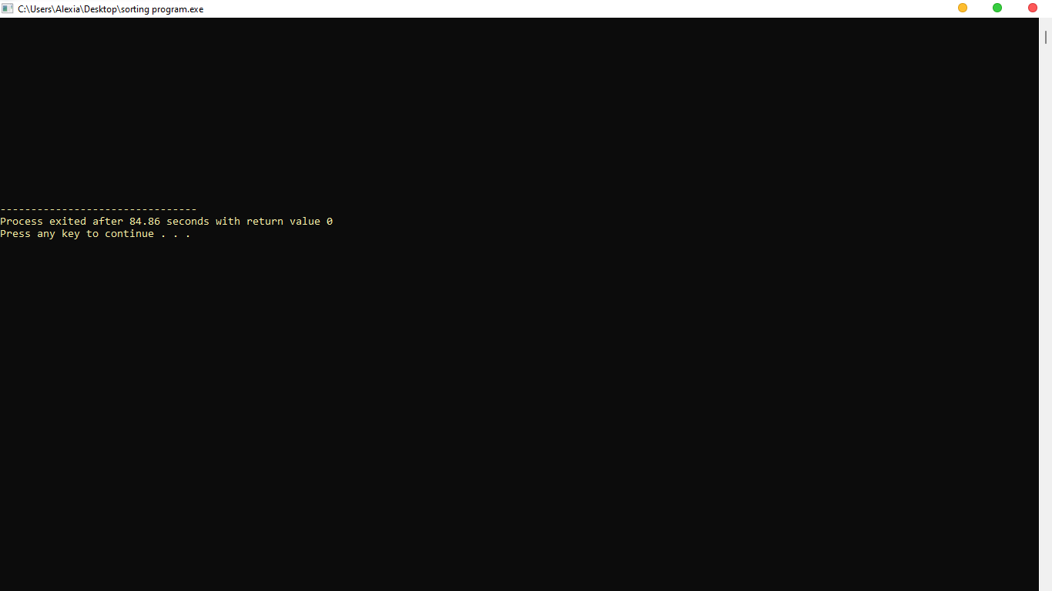

Berikut adalah kode script yang saya buat

#include <iostream>

#include <string>

using namespace std;

int main(){

system("COLOR F");

int ahoy=1;

for(int i=1; i<2; i++){

printf("\n\n\t==========TUGAS PERTEMUAN 1==========\n\n");

string nama("RIFANDY ARNAS");

string nim("232310001");

string kelas("TI-23-PA");

kelas.append(" (LAB 2)");

cout<<"\tNama\t: "<<nama;

cout<<"\n\tNIM/NPM\t: "<<nim;

cout<<"\n\tKelas\t: "<<kelas;

ahoy++;

}

if(ahoy==2){

printf("\n\n\t<<<<<<<<<<Bubble Sort<<<<<<<<<<\n\n");

string matkul("Design dan Analisis Algoritma");

string tanggal("15 Maret 2024");

tanggal.append(" (Pembuatan Script)");

cout<<"\tMatkul\t: "<<matkul;

cout<<"\n\tTanggal\t: "<<tanggal;

}

printf("\n\n\tList Program kali ini!");

printf("\n\t[1] GETSUKU Program");

printf("\n\t[2] TOSHOKAN Program");

int pilihan;

cout<<"\n\n\tPilihan kamu (ketik 1/2) [1/2]: "; cin>>pilihan;

if(pilihan==1){

goto getsuku;

}

else if(pilihan==2){

goto toshokan;

}

else{

system("cls");

cout<<"\n\n\n\tPilihan yang kamu pilih ga ada!";

cout<<"\n\n\tBye!! [Sistem Exit]";

cout<<endl<<endl<<endl<<endl<<endl<<endl<<endl;

cout<<endl<<endl<<endl<<endl<<endl<<endl<<endl;

exit(0);

}

getsuku:

system("cls");

system("COLOR 9");

printf("\n\n\t////////////////////GETSUKU////////////////////\n\n");

printf("\tSelamat datang di program GETSUKU!");

printf("\n\n\tProgram ini akan mensortir angka yang kamu mau!");

printf("\n\tSelamat Mencoba!\n\n");

int sort[10000];

int sort_size;

cout<<"\t------------------------------------------";

cout<<"\n\tKetik jumlah angka yang mau di sortir: ";

cin>>sort_size;

cout<<"\t------------------------------------------";

cout<<"\n\n\t------------------------------------------";

cout<<"\n\tKetik [angka bebas] dan tidak melebihi 10000!";

cout<<endl<<endl;

for(int i=0; i<sort_size; i++){

cout<<"\tAngka ke-"<<i+1<<": ";

cin>>sort[i];

}

cout<<"\t------------------------------------------";

cout<<"\n\n\t------------------------------------------";

cout<<"\n\tData Awal: ";

for(int i=0; i<sort_size; i++){

cout<<sort[i]<<" ";

}

cout<<"\n\t------------------------------------------";

cout<<"\n\n\t------------------------------------------";

cout<<"\n\tSorting Process [Ascending]";

cout<<"\n\t------------------------------------------";

int backup;

for(int i=0; i<sort_size; i++){

int marine=1;

for (int j=0; j<sort_size-1; j++){

if(sort[j]>sort[j+1]){

backup=sort[j];

sort[j]=sort[j+1];

sort[j+1]=backup;

marine++;

}

}

if(marine==1){

break;

}

cout<<"\n\t"<<i+1<<"th Sorting Process: ";

for(int k=0; k<sort_size; k++){

cout<<sort[k]<<" ";

}

cout<<endl;

}

cout<<"\t------------------------------------------";

cout<<"\n\n\t------------------------------------------";

cout<<"\n\tHasil Sorting: ";

for(int i=0; i<sort_size; i++){

cout<<sort[i]<<" ";

}

cout<<"\n\t------------------------------------------";

cout<<"\n\n\t------------------------------------------";

cout<<"\n\tData Awal [Hasil sorting Ascending]: ";

for(int i=0; i<sort_size; i++){

cout<<sort[i]<<" ";

}

cout<<"\n\t------------------------------------------";

cout<<"\n\n\t------------------------------------------";

cout<<"\n\tSorting Process [Descending]";

cout<<"\n\t------------------------------------------";

int backup1;

for(int i=0; i<sort_size; i++){

int hoshou_marine=1;

for(int j=0; j<sort_size-1; j++){

if(sort[j]<sort[j+1]){

backup1=sort[j];

sort[j]=sort[j+1];

sort[j+1]=backup1;

hoshou_marine++;

}

}

if(hoshou_marine==1){

break;

}

cout<<"\n\t"<<i+1<<"th Sorting Process: ";

for(int k=0; k<sort_size; k++){

cout<<sort[k]<<" ";

}

cout<<endl;

}

cout<<"\t------------------------------------------";

cout<<"\n\n\t------------------------------------------";

cout<<"\n\tHasil Sorting: ";

for(int i=0; i<sort_size; i++){

cout<<sort[i]<<" ";

}

cout<<"\n\t------------------------------------------";

int yoshi_ichi;

cout<<"\n\n\tApakah mau lanjut ke program lain?";

cout<<"\n\tAtau mau mengulang program ini?";

cout<<"\n\t[1]Lanjut";

cout<<"\n\t[2]Mengulang";

cout<<"\n\t[3]Exit";

cout<<"\n\n\tPilihan kamu [1/2/3]: "; cin>>yoshi_ichi;

if(yoshi_ichi==1){

goto toshokan;

}

else if(yoshi_ichi==2){

goto getsuku;

}

else{

system("cls");

cout<<endl<<endl<<endl<<endl<<endl<<endl<<endl;

cout<<endl<<endl<<endl<<endl<<endl<<endl<<endl;

exit(0);

}

toshokan:

system("cls");

system("COLOR E");

printf("\n\n\t////////////////////TOSHOKAN////////////////////\n\n");

printf("\tSelamat datang di program TOSHOKAN!");

printf("\n\n\tProgram ini akan mensortir nama buku yang kamu mau!");

printf("\n\tSelamat Mencoba!\n\n");

string bukusrt[100];

int bukusrt_size;

cout<<"\t------------------------------------------";

cout<<"\n\tKetik jumlah buku yang mau di sortir: ";

cin>>bukusrt_size;

cout<<"\t------------------------------------------";

cout<<"\n\n\t------------------------------------------";

cout<<"\n\tKetik [nama buku] dan tidak lebih 100 karakter!";

cout<<endl<<endl;

for(int i=0; i<bukusrt_size; i++){

cout<<"\tBuku ke-"<<i+1<<": ";

cin>>bukusrt[i];

}

cout<<"\t------------------------------------------";

cout<<"\n\n\t------------------------------------------";

cout<<"\n\tData Awal: ";

for(int i=0; i<bukusrt_size; i++){

cout<<"|"<<bukusrt[i]<<"| ";

}

cout<<"\n\t------------------------------------------";

cout<<"\n\n\t------------------------------------------";

cout<<"\n\tSorting Process [Ascending]";

cout<<"\n\t------------------------------------------";

string buku;

for(int i=0; i<bukusrt_size; i++){

int chloe=1;

for (int j=0; j<bukusrt_size-1; j++){

if(bukusrt[j]>bukusrt[j+1]){

buku=bukusrt[j];

bukusrt[j]=bukusrt[j+1];

bukusrt[j+1]=buku;

chloe++;

}

}

if(chloe==1){

break;

}

cout<<"\n\t"<<i+1<<"th Sorting Process: ";

for(int k=0; k<bukusrt_size; k++){

cout<<"|"<<bukusrt[k]<<"| ";

}

cout<<endl;

}

cout<<"\t------------------------------------------";

cout<<"\n\n\t------------------------------------------";

cout<<"\n\tHasil Sorting: ";

for(int i=0; i<bukusrt_size; i++){

cout<<"|"<<bukusrt[i]<<"| ";

}

cout<<"\n\t------------------------------------------";

cout<<"\n\n\t------------------------------------------";

cout<<"\n\tData Awal [Hasil sorting Ascending]: ";

for(int i=0; i<bukusrt_size; i++){

cout<<"|"<<bukusrt[i]<<"| ";

}

cout<<"\n\t------------------------------------------";

cout<<"\n\n\t------------------------------------------";

cout<<"\n\tSorting Process [Descending]";

cout<<"\n\t------------------------------------------";

string buku1;

for(int i=0; i<bukusrt_size; i++){

int sakamata_chloe=1;

for (int j=0; j<bukusrt_size-1; j++){

if(bukusrt[j]<bukusrt[j+1]){

buku1=bukusrt[j];

bukusrt[j]=bukusrt[j+1];

bukusrt[j+1]=buku1;

sakamata_chloe++;

}

}

if(sakamata_chloe==1){

break;

}

cout<<"\n\t"<<i+1<<"th Sorting Process: ";

for(int k=0; k<bukusrt_size; k++){

cout<<"|"<<bukusrt[k]<<"| ";

}

cout<<endl;

}

cout<<"\t------------------------------------------";

cout<<"\n\n\t------------------------------------------";

cout<<"\n\tHasil Sorting: ";

for(int i=0; i<bukusrt_size; i++){

cout<<"|"<<bukusrt[i]<<"| ";

}

cout<<"\n\t------------------------------------------";

int yoshi_ni;

cout<<"\n\n\tApakah mau exit atau mengulang program ini?";

cout<<"\n\tAtau mau mengulang program sebelumnya?";

cout<<"\n\t[1]Mengulang GETSUKU";

cout<<"\n\t[2]Mengulang TOSHOKAN";

cout<<"\n\t[3]Exit";

cout<<"\n\n\tPilihan kamu [1/2/3]: "; cin>>yoshi_ni;

if(yoshi_ni==1){

goto getsuku;

}

else if(yoshi_ni==2){

goto toshokan;

}

else{

system("cls");

cout<<endl<<endl<<endl<<endl<<endl<<endl<<endl;

cout<<endl<<endl<<endl<<endl<<endl<<endl<<endl;

exit(0);

}

cin.get();

return 0;

}